**ĐỀ THI TIẾNG ANH Mã đề: 18**

**Trình độ A2**

Họ và tên thí sinh: ……………..……………………………………………………….……………………………………………………………….

Số báo danh: ……………..…………………………………………...……. Phòng thi số: …………………………….…………………

**PAPER TWO LISTENING (Approximately 15 minutes)**

**PART 1: Questions 1 – 5**

*There are five questions in this part. For each question there are three answer choices and a short recording. Tick (***√***) the correct answer. You will hear the piece twice.*

*Example:* ***How many people were at the meeting?***

*A. 3 B. 13* **√** *C. 30*

**1.** What does the woman order?

 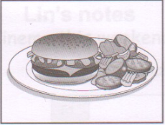 

**A** □ **B** □ **C** □

**2.** What size boots is the woman going to try on next?

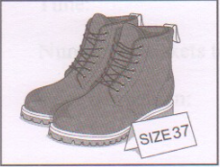  

**A** □ **B** □ **C** □

**3.** Where will the man get off the bus?

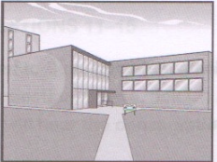  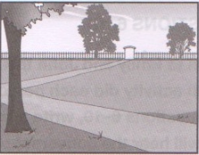

**A** □ **B** □ **C** □

**4.** How many books does the boy want to borrow?

  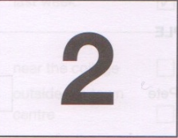

**A** □ **B** □ **C** □

**5.** What job does Mark’s brother do?

  

**A** □ **B** □ **C** □

**PART 2:** **Questions 6-10**

*Listen to Emily and John talking about activities they did last weekend. Which activity did each person do? For questions 6-10, write a letter A-H next to each person. You will hear the conversation twice.*

|  |  |  |
| --- | --- | --- |
| **EXAMPLE** | **ANSWER** |  |
| **0**  John | **C** |  |
| **PEOPLE** |  | **ACTIVITIES** |
| **6**  Pete  **7** Emily  **8**  Jenny  **9**  Joe  **10** Andy |  | **A** basket ball  **B** cycling  **C** fishing  **D** football  **E** skate boarding  **F** swimming  **G** table-tennis  **H** tennis |

**PART 3:** **Questions 11-15**

*Listen to Suzy talking to a friend about a new shop*

*For questions* ***11-15****, tick (√)* ***A****,* ***B****, or* ***C****. You will hear the conversation twice.*

Example: **0.** When did the new shop open?

A. today

B. yesterday

√C. last week

**11.** Where is the new shop?

A. near the college

B. outside the town centre

C. opposite the newsagent’s

**12.** In the shop you can buy

A. clothes

B. bags

C. boots

**13.** What time does the shop close on a Thursday?

A. 6 p.m

B. 8 p.m

C. 10 p.m

**14.** What days does the shop open?

A. Tuesday to Sunday

B. every day

C. Monday to Friday

**15.** What should Suzy’s friend do if she wants a job?

A. phone the manager

B. go to the shop

C. write a letter